Hogan’s 2015 Motorcycle Trip
St. Louis KC 250 Miles
KC Topeka 65 Miles
I-70 the whole way.
Topeka Junction City KS 65 Miles
Junction City Salina 50 Miles
I-70 All the Way
Salina Hays 100 Miles
I-70 All the Way
Hays Colby 110 Miles
I-70 All the Way
Colby Denver 240 Miles
Denver Hwy 74 South Mile Marker 252
About 1 mile South on 74, go RIGHT on Highway 66 also called Squaw Pass Rd. Road will become Highway 103/Squaw Pass Rd.
At Echo Lake Lodge/ Highway 5, turn LEFT to go South on Highway 5.
This road is Mount Evans Road. Take it to the end and come back, its Beautiful! 8 ish
miles each way.
Back at Echo Lake Lodge, take 103 North to Idaho Springs

Idaho Springs Georgetown 15 Miles
EXIT 228 Mile Marker 15th street
Take Geneva Rd (62)/Guanella Pass Rd / 381 South to Grant Colorado.
Go West/Right on Hwy 285 for 62 miles to Johnson Villiage
Continue on Hwy 285 to Poncha Springs, CO 25 miles
Take Hwy 50 West to Montrose, CO 125 miles 2.5hour
Million Dollar Highway!!!!!
Montrose South to Durango Hwy 550 South 110 miles
Durango to Pagosa Springs Hwy 160 East 60 miles
Continue on Hwy 160 East/North 60 miles to Del Norte, CO

Del Norte take Hwy 112 East to Hooper, CO 30 miles
Take Hwy 17/285 north to Poncha Springs, CO 60 Miles
Hwy 50 East 60 ish miles towards Canon City, CO
Take Hwy 3 South (almost a U-Turn). Will be brownish building “American Adventure Expeditions” at the corner. Before the Arkansas River.
Follow 3 until it meets CO RD 3a which is the road that goes over and through the Royal Gorge.
After Royal Gorge, continue on CO Rd 3a until it meets back up with Hwy 50 and continue to Canon City, CO
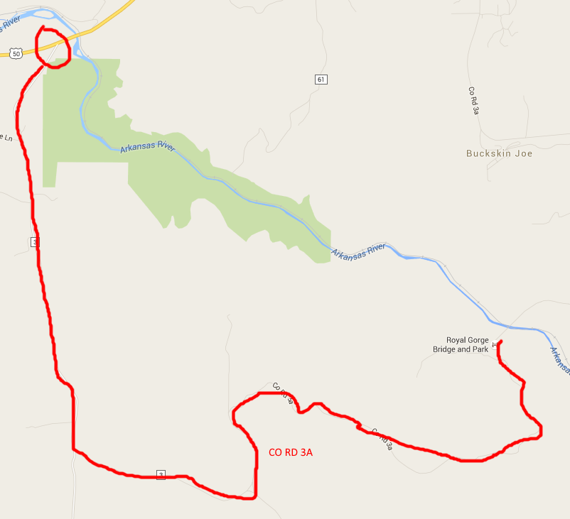

Just outside of Canon, take Hwy 67 North/ Phantom Canyon Road Stoplight with road sign “SH 67” left turn.
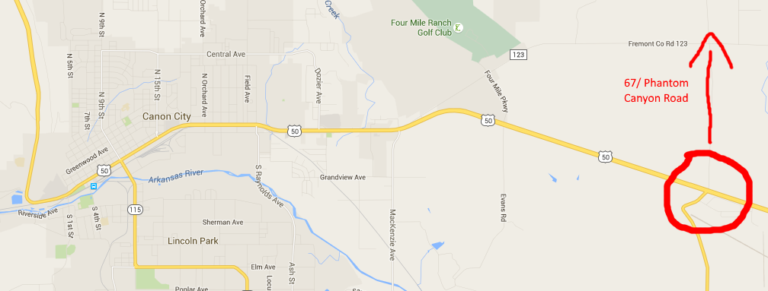
Its about 45 miles of gravel road to Victor, CO
In Victor, continue on HWY 67 North 20 Miles to Divide, CO
Meet Hwy 24 and go East to signs for Pikes Peak
I-25 S | Pueblo, CO | 60
Pueblo, CO | Garden City, KS 50 E | 225
Garden City | Dodge City 50 E | 60
Dodge City | Wichita, KS 400 E | 156
Wichita, KS | El Dorado, KS | 30
El Dorado, KS | Camdenton, MO | 250
Camdenton, MO | Home | 170

